
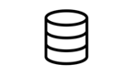




Data Preprocessing
Training dataset
Test dataset
Split data
Model Training
Training
Model building, training & validation
LSTM
ANN
RF
Xgboost
Adaboostt

DT

RR

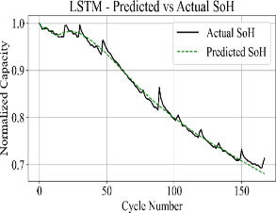

Performance Evaluation
MSE
RMSE
MAE
R2 SCORE

Performance Evaluation
SOH Estimation Training Model
SOH Prediction
Raw data
Validation

